Top tips for preparing a direct application for BASES support accreditation

- Be Concise and make your application easy to follow: Any application for BASES accreditation is limited to 100 pages in total. Thus, it is extremely important that the application is concise and easy to follow. Reviewers are looking to see if the evidence you present in your application meets the criteria across the 10 competency areas for BASES accreditation. Thus, it is vital that the reviewer can easily locate the evidence against the specific criteria.

- Include Hyperlinks to your appendices and ensure you narrate them too: In relation to, Point 1 when completing your BASES competency profile try hyperlinking to the appendices where the evidence for meeting the specific criteria is provided. This will make it far easier for the reviewer to locate the evidence. Furthermore, make sure there is a narrative to any evidence presented in the appendices. For example, often in applications some in-house club data may be presented to demonstrate evidence of communication as a competency. This should not just be inserted in the appendices without a narrative that clearly states who collected the information, who developed the system used at the club and the impact/implications of the data. Absence of this information is a real “pet-hate” of reviewers.

- The Case study is very important: From a reviewers perspective it is one of the only aspects of the application that helps reviewers judge the level of competency that a practitioner operates at in the field. Furthermore, the case study offers an opportunity to evidence many of the competencies required for BASES accreditation (e.g., technical skills, application of knowledge and skills, understanding and use of research, self-evaluation and professional development, communication, problem solving and impact, and understanding the delivery environment). Figure 1 provides a summary of important points to remember to include in your case study that are often not considered or included by applicants. For more details on writing the case study, please see the article by Jones et al. (2020) in ‘The Sports and Exercise Scientist’ or visit the BASES website for some example case studies.

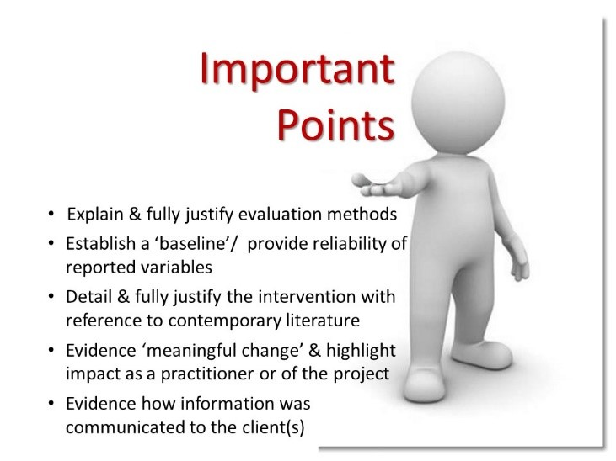
Figure 1. A summary of important points to consider when writing the case study.

- Define your scope of practice and consider your accreditation category carefully: The application must include a section titled ‘applicant’s personal philosophy to their own work’. Within this section you must clearly outline your scope of practice, before then ensuring that the reported case study ‘fits’ within this scope of practice, for example:

‘an applicant working with sedentary individuals only to develop health and fitness and possesses specific skills spanning physiology [health and fitness assessments and exercise prescription] and psychology [behaviour change] within an interdisciplinary support service’

• If you don’t clearly outline your scope of practice from a reviewer’s perspective, this places doubt that you can operate safely within your boundaries of expertise. A common error in some applications is that applicant’s seem bound to ‘fitting their skills and competencies’ to one of the 3 main disciplines of sports science (Biomechanics, Physiology & Psychology), when their scope of practice fits within the ‘interdisciplinary’ domain. For instance, applicants who work as a ‘strength and conditioning coach’ apply for accreditation in Physiology, when the scope of practice is best described as a ‘task-specific interdisciplinary’ [An individual who has a broad knowledge base across the disciplines (in this case primarily physiology and biomechanics) which is sufficiently in-depth in one area to allow a full understanding of a particular problem] (BASES, 1997). Therefore, prior to preparing your application carefully define your scope of practice and consider which category of accreditation you should be considered for.

- Anonymise work with any clients included in the application. It is important to anonymise the client(s) name(s) within the case study or other examples of applied work with clients contained within the application. Failure to do this may lead to referral or rejection of the application as this would fail to demonstrate competencies under section 10 (Professional Relationships and Behaviours).

- Ensure references reflect the domain of expertise you are applying for: Applications must include references from a mentor and 2 clients for support accreditation. Please ensure that the references reflect the domain of expertise that is being applied for. Thus, if support, the references must reflect applied work undertaken, likewise for research and pedagogy. Although, such errors of inappropriate references against the domain of expertise are rarely seen.

- Completed a Non BUES degree? Complete the Non BUES template making reference to specific modules: Section 1 (scientific knowledge) of the BASES competencies can be evidenced entirely by inclusion of evidence that you possess a BASES endorsed undergraduate degree in sports and exercise science and / or BASES recognised postgraduate qualification in sport and exercise science. However, as often is the case applicant’s may have a undergraduate sports science degree, but one that is not endorsed by BASES or have a degree, but not directly in sports science. Therefore, these applicants need to complete a ‘Non BUES evidence of knowledge template’ whereby applicants need to evidence hours (based on credits achieved in their degree) in each of the disciplines of sports science (biomechanics, physiology, psychology, inter-disciplinary, research methods, etc.). If you are required to complete this template, it is very useful here if you complete the form by making reference to specific modules (module titles ideally stated on the form) from your undergraduate or postgraduate transcripts to make this entirely transparent. Specific guidance on completing this form can be found in the BASES accreditation guidelines.

- Include a CPD Log and include reflection along each CPD activity: Often applicants will include details of additional courses, workshops and other CPD attended or undertaken as evidence for achievement of specific competencies under Sections 5 (Self Evaluation and Professional Development) and 8 (Management of Self, Others and Practice) of the BASES competency profile. Another ‘pet-hate’ of reviewers is that this requires a little more than just inserting a copy of the certificate from the course or workshop attended as evidence of; ‘being able to maintain an appropriate audit trail and work toward continual improvement’ (5.3), ‘take responsibility for continuous performance improvement both at a personal level and in a wider organisational context’ (5.5), and ‘a commitment to professional development through continuing advancement of own knowledge, understanding and competence’ (8.2). It is advisable to include a CPD log (table format) and against each CPD activity providing some reflection on how the activity has enhanced your practice. This then shows that the CPD undertaken is part of plan and demonstrates competencies within section 5 and 8 related to reflective practice (e.g., ‘be able to adapt their practice as a result of new and emerging ideas and information with the area of sport and exercise science’ [5.2], ‘understand the value of reflection in practice and evidence of engagement in the process’ [5.4]).

- Demonstrate your ability to communicate with a range of audiences: The application needs to show evidence of communication to a variety of audiences to demonstrate the ‘ability to communicate orally and in writing to colleagues, peers and clients’ (section 6 of the BASES competencies). For support accreditation, this primarily needs to evidence communication to clients (e.g., athletes and coaches), and may include examples of communication within the science and medicine support team. In the case of the former, showing examples of how you communicate ‘the science’ to the lay public who do not have a background in sports and exercise science (e.g., translating the science to the end user). The case study provides an opportunity to demonstrate this ability (see Jones et al., 2020) and may be supplemented with further examples of data presentation or oral communication (e.g., PowerPoint slides from an educational session) [As highlighted above any examples like this must include a narrative to explain the context of this example of communication]. A novel approach to demonstrate oral communication could be inserting links to video examples of some form of delivery (i.e., instructing/ coaching, presentation to clients, etc.) to clients via You Tube or Microsoft Streams. If possible even though the application is focused on support accreditation, any peer-reviewed publications or conference communications should be stated, as this demonstrates additional evidence of communication, but to a scientific audience.

- Ensure you demonstrate Impact: the application should display where the applicant has they have had impact in their role. The case study is a good way of demonstrating this, but also consider how to demonstrate through other means e.g. reflection, development etc.

- Don’t presume the reviewer has an in depth understanding of your area if it is a niche area. If your application involves a case study or role in a niche area ensure you can show a full demonstration of competencies particularly technical ability. Don’t assume the reviewers will understand your niche area and how it includes a full range of technical skills.

- Detail examples of your reflective practices: Often applicants demonstrate a reflection model they use but fail to demonstrate their reflective practices in situ. Use examples of how and when you have reflected and the impact/change that it led to. Ensure you not only describe your method of reflective practice but provide detailed examples of how you have used it in your practice either for yourself or in managing others.

- Finish your case study appropriately: Often case studies end abruptly after the results section. Always reflect on the cases study, your role, impact and outcomes and summarise well and succinctly with for future directions.

- Read successful applications: Read someone else’s successful application ahead of submitting yours. It will save you a lot of time if you understand what a successful application is. These can be found in the ‘Case study and Profile support’ section on the accreditation page on the website.

References
BASES, (1997). Interdisciplinary Section Future Directions. The British Association of Sport and Exercise Sciences, December 1997.
Jones, P.A., Gilchrist, S., and Barnes, C. (2020). Preparing a case study for BASES support accreditation: a reviewer’s perspective. The Sports and Exercise Scientist. (Autumn Edition).

